System.out.printf(format, items);

Format is a string that may consist of substrings and format specifiers. Format specifier specifies

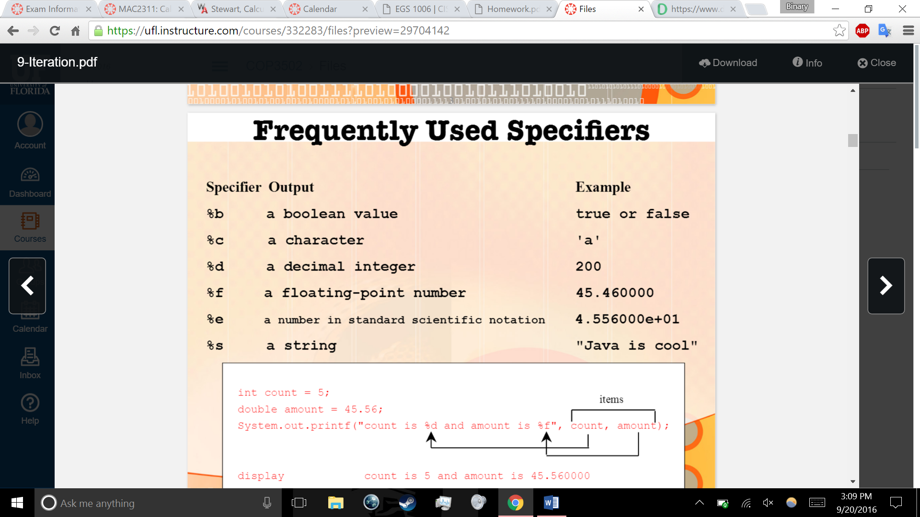

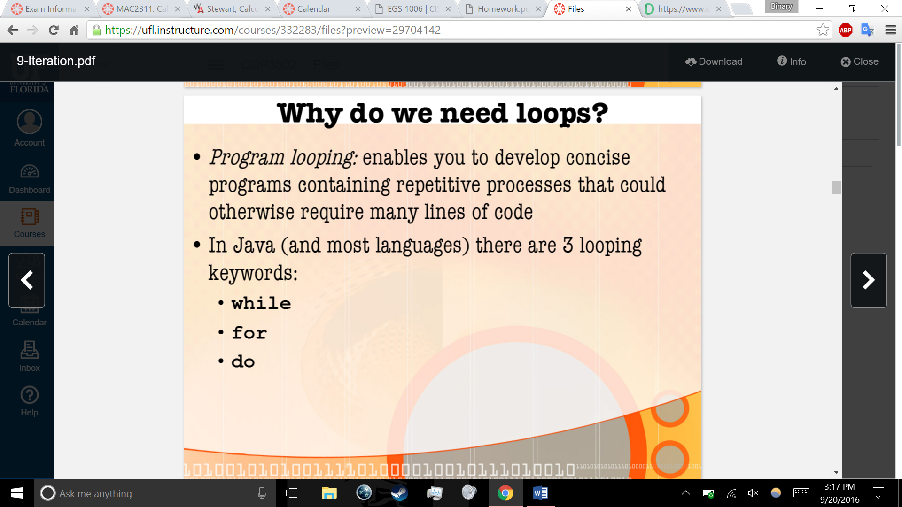

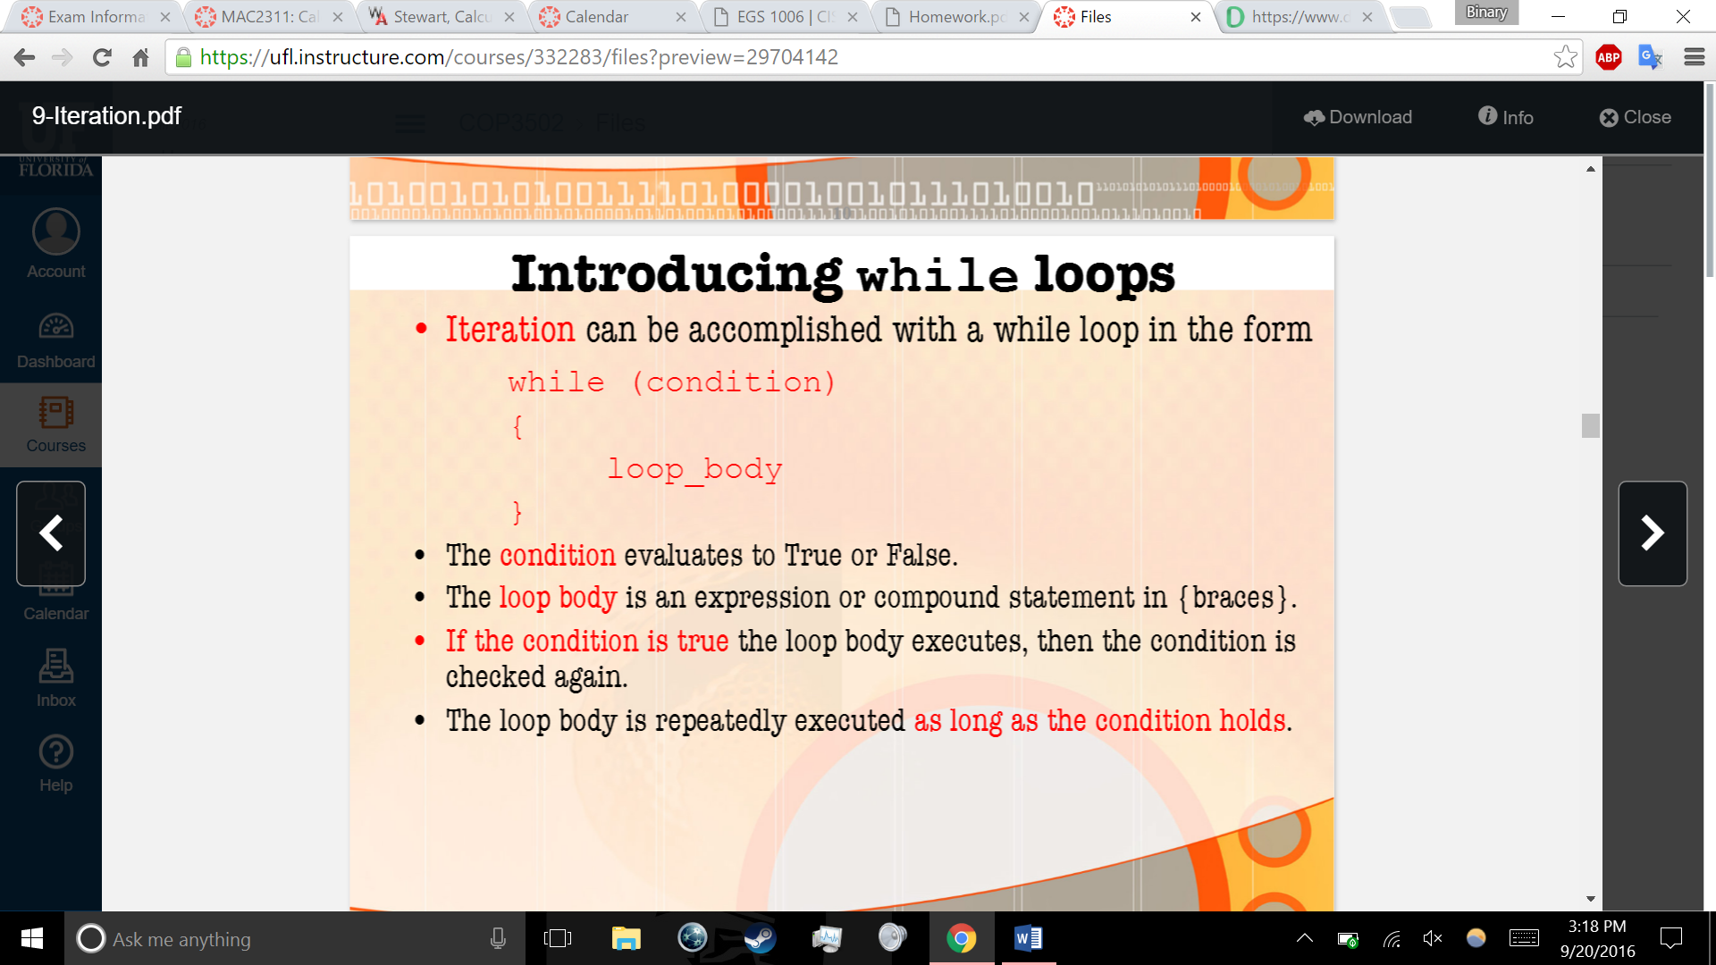

While guess != number